Golf
  - 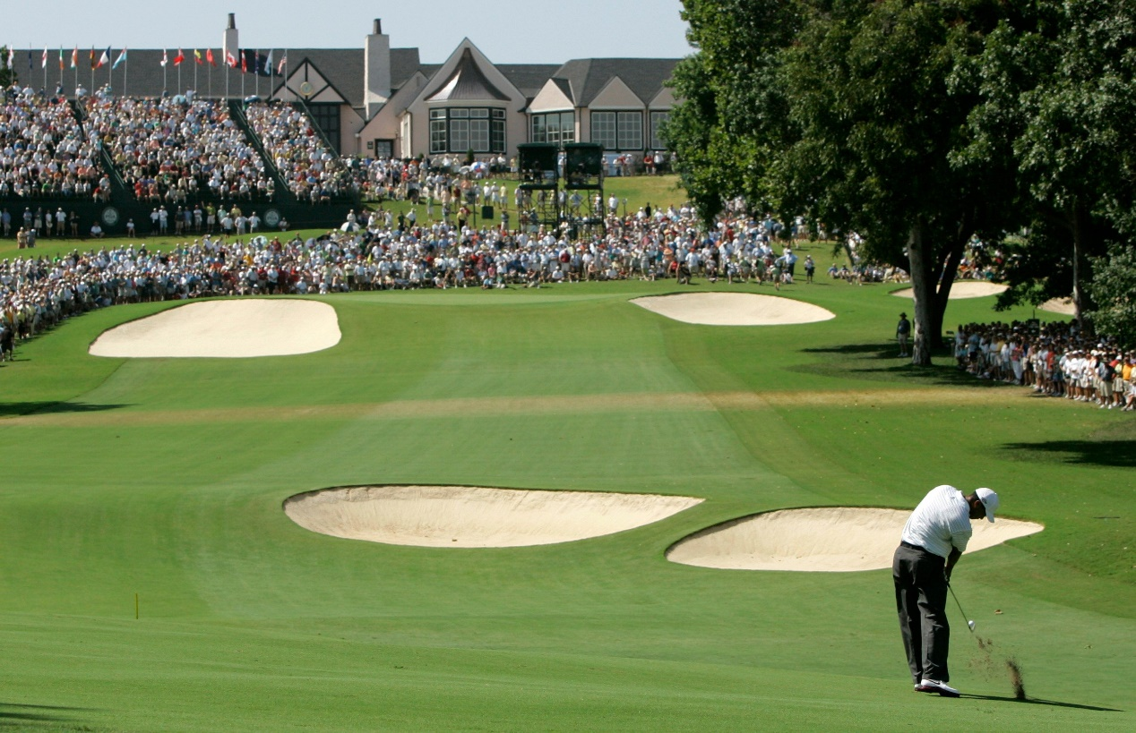
  - Element of Culture

Author
Cohen Sheridan
1.0 Introduction | 1  1-2  2-5  2-5  5  6-8  6-7  7-8  9-11  9-10  10-11  12-13  13-14
2.0 Dispersal of Golf
3.0 Diffusion of Golf
3.1 Factor One – Advancements in transport telecommunications
3.2 Factor Two – The role of Trans National Corporations (TNC’S)
4.0 Case Studies
4.1 Case Study One – Adapting to Golf
4.2 Case Study Two – Resisting Golf
5.0 Implications of Change for golf

5.1 Implications of change in the nature of golf

5.2 Implications of change in the spatial distribution of golf
6.0 Likely future changes in the spatial distribution of Golf
7.0 Bibliography
Table of
Contents

1.0 Introduction
The purpose of this report is to describe the sport of golf and relate it to being an element of culture. Culture is the beliefs, customs and traditions of a specific group of people. Culture encompasses the social behavior and norms found in human societies aswell. Some religious beliefs or cultural backgrounds influence the physical activity they choose to play. An example of this is golf, because it has a specific cultural background and it is now played all over the world.

2.0 Dispersal of Golf
The Scottish sport known as Golf had one distinguishing feature that set it apart from other sports at the time known as the hole. Golf history can be traced back to the 15th century Scotland when we're talking about the current game with 18 holes.
In the history of golf, Scottish troops, emigrants, and expatriates had a significant impact. During the 18th century, they were in charge of expanding the game throughout the British Isles which was where it was then spread around the British Empire.
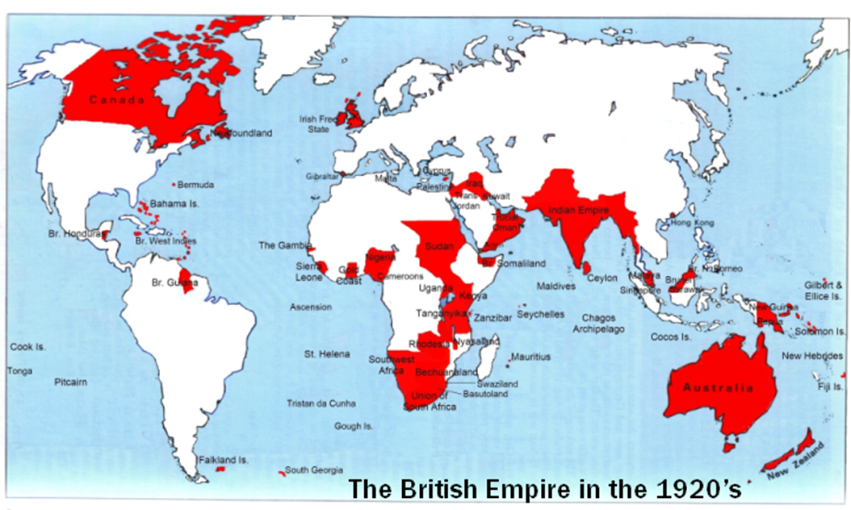
The dispersal of golf from Scotland to the British Isles, then to the rest of the British Empire is shown below. https://general-history.com/the-british-empire-in-1920/

By 1880, golf had spread to Ireland, many other parts of Europe, Australia, New Zealand, Canada, Singapore, and South Africa. Like most other countries of the world that adopted the sport early, the sport did not gain popularity in the United States until the early nineteenth century.
The United States Golf Association was founded in 1894 to serve as ambassadors for the game in the United States, which included 267 golf clubs by 1910. Golf is known around the globe and has gained popularity, as it is becoming more televised and marketed.
The 1920’s can be said to be where golf really took off, as the US is the biggest player of the sport right now. Tournament golf had become a well-established spectator sport in the United States by the 1920s and has been gaining popularity ever since. PGA of America was formed in the US in 1916 from Rodman Wanamaker, a Philadelphia businessman.

3.0 diffusion of Golf
For most of human history information could not travel faster than the person carrying it such as on a horse, ship or train. Information could travel faster than human such as aeroplanes, carrier pigeons and smoke signal. Over the last two centuries, the distance in kilometers between places have stayed the same, however the distance in time has shortened due to improvements in transport and telecommunication technology. Advancements in transport and telecommunication helped the diffusion of golf to all parts of the world. Examples of transport advancements that helped diffuse golf include Containerization, steam ships, aeroplanes, and trains. Examples of telecommunication advancements that helped diffuse golf include television, advertising, radio and the internet, (social media).

3.1 factor one – advancements in transport telecommunications
What are some advancements in telecommunications that led to the diffusion of golf?
Golf has become an increasingly popular sport in the past century and media can credit itself for the substantial impact on this sport. Professional players didn't have any outlets before social media to communicate their stories and daily lives with a larger audience than the members of their country clubs. In order to achieve greater popularity and attention, golfers nowadays frequently communicate with their fans and share golfing videos. (Rickie Fowler, who has 5 million followers on all social media platforms, often shares photos and videos of him at junior golfing and charity events.)
Radio broadcasting has led to the diffusion of golf because it let people be able to listen to the professional scores and the commentating of the big tournaments such as the US Masters. Radio also changed the way Society saw sports. The introduction of radio play-by-play explanations of sporting events brought sports enjoyment into the homes of millions of people. Radios became a dominant feature in American homes in the 1920s after being introduced during World War I. Over the course of the decade, hundreds of radio stations popped up.
Print advertising, Advertisements in print can be seen in newspapers or magazines, and they are occasionally combined with brochures or posters. Print advertising includes anything written with a goal to attract the attention of a specific target audience. People who read newspapers or other media have just a tendency for looking through the print advertisements that they come across. Print advertising would have aided in the diffusion of golf in the 1900’s because everyone was using newspapers that had ads about golf.

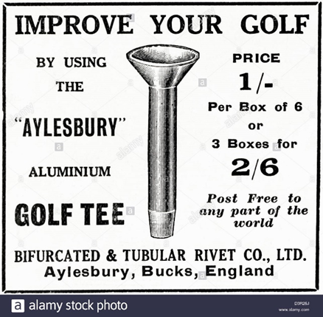
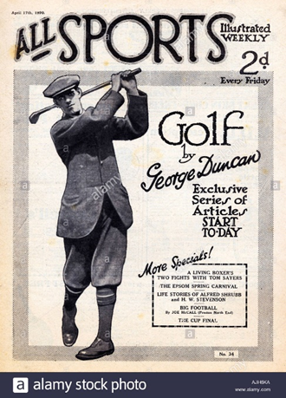




Television, because of television, the diffusion of golf has remarkably increased. This is because golf is seen on sporting channels for everyone to watch. The big tournaments and pro players can be viewed on television for new and current golf players without leaving their home, such as Tiger Woods or the British open. Advertising is also commercialized on TV for golf, which also influences the diffusion of clubs and equipment to other countries.
What are some advancements in transport that led to the diffusion of golf?
Containerization allows loads of goods to be moved on, off and between ships, trains and trucks much more easily. Containerization allows golfing equipment such as clubs, gloves, shoes, balls etc. to be transported to different countries in bulk amounts, cheaply, which is more inviting to new players because it is seen as not a wealthy person sport anymore and there are cheaper ways to be able to play.
Steam ships were once the only way for transport between countries which had an impact because it allowed professionals to play in different competitions across the world. Steam ships also developed because of containerization.
Trains were a fast way for professionals and/or golf products to travel across land to other cities or countries. St Andrews (home of golf) railway station served the town of St Andrews, Fife, Scotland from 1887 to 1969 on the St Andrews Railway and the Anstruther and St Andrews Railway.
Aeroplanes is the modern and fast way for professionals to get across the world to play golf tournaments. Aeroplanes are becoming cheaper to use now and because of this people can fly over to golf courses they dream of playing aswell as the professionals to play in Australia one day then in Scotland in a few days instead of a few weeks for example.

3.2 factor two – role of Trans-National Corporations (TNC’s)
How did the role of TNC’s diffuse golf?
Trans-National Corporations (TNC’s) or multinational corporations are companies that operate in more than one country, an example of this is the PGA TOUR. PGA TOUR members come from around the world. In 2020-21, there are 96 international members from 29 countries and outside the United States. The 2020-21 PGA TOUR Schedule includes 50 official FedEx Cup tournaments, in addition to the men's Olympic Golf competition.

The PGA of America evolved into mostly a club professional organisation, but it kept control of two major events: the PGA Championship and the Ryder Cup. Due to the United States' expected dominance, the Ryder Cup was an obscure match play team event that was not very popular with golf fans. It became increasingly competitive after the addition of players from continental Europe in 1979 and improved television coverage, and it evolved into the main international team event, which is currently dominated by Europe. Both events generate significant money for the PGA of America.
To the right is the logo of the PGA Tour which was started in 1929.
https://en.wikipedia.org/wiki/PGA_Tour#/media/File:PGA_Tour_logo.svg

4.0 CASE STUDIES
These are two different cases that have integrated the element of culture studied (golf) differently: The Chinese Government resists the integration of golf and an Indian group of people adapts to be able to play golf.
4.1 Case Study One – Adapting to Golf

Slum golf: The sport that stormed the streets of Mumbai. https://www.theguardian.com/cities/2019/feb/11/slum-golf-the-sport-that-stormed-the-streets-of-mumbai
When a group of young caddies who worked on a golf course were told they weren’t allowed to play because of ‘exclusivity’, they got creative.
Anil Bajrang Mane grew up in a slum in Chembur, a suburb of Mumbai. When Mane was just 14, he dropped out of school to become a caddie. When Anil was 17, he had his first swing when a club member handed him a 7 iron and told him to have a swing. The 150-yard shot changed his life, he says.
The club didn’t allow caddies to play on the course, because they insisted that it would affect its “exclusivity”. Mane earned his livelihood in a world that wouldn’t allow him to participate.
Mane and his friends perfected a different game, one they called “slum golf”.
Slum golf is played in the narrow streets and alleyways. Their “teeing ground”, “fairway” and “hazards” include houses, walls, drains, construction debris, parked vehicles, sleeping dogs, garbage dumps, stray cows and potholes.
They play with cheap plastic ping pong balls and clubs made from construction rebar, fitted with hosepipe for grips.
When Mane and his friends play, they wager 50 rupees each and the winner takes the lot.
Although the club has since slightly relaxed its rules – it now allows caddies to use the club on Mondays when it is closed to members. Anil and his friends still play slum golf for fun especially during the wet/monsoon months.
4.2 Case Study Two – Resisting Golf

Honma tour player Zhang Lian-Wei was China's most successful professional golfer, who hit first tee shot in PGA Tour China history. https://www.golfpunkhq.com/special-report/article/88-million-people-in-china-banned-from-golf

Golf was banned up until the middle of the 1980s by the Communist Party of China as being too upper-middle class and materialistic.
The first golf course was then constructed in China in 1984. It was the Chung Shan Hot Springs in Zhongshan, based on a design by Arnold Parmer. The first international tournament held in China was the 1995 World Cup at Mission Hills in Guangdong province.
Another ban in 2004 limited the number of golf courses in China due to environmental impact concerns. Although this ban was put in place the number has still tripled since 2004. At that time, only 170 courses existed.
By 2009 there were almost 600. Around 2008, growth rate of the golf industry is 25 to 30 percent per year. 2011, the rate was adjusted by the government and was decreased to 7.5% which is 45 new courses.
January 2017 the number of golf courses rose to 638, when the government ordered 111 of them closed due to water and land conservation concerns. At that time, all of China's province-level divisions except Tibet had at least one course in operation.
At the 2007 National People’s Congress, acknowledging that the construction of new golf courses is a waste of public money and use of space, Premier Wen Jiabao said to the Congress that contracts in building new golf courses should be discouraged.
The government has put a 24% tax on golf clubs.
October 2015, the Chinese Communist Party banned all its members from joining golf clubs among other displays of extravagance as part of China's anti-corruption campaign.
For the general public, golf in China is considered to be prohibitively expensive. However, it is seen as the top recreational sport for businesspeople and officials.
5.0 Changes in the Nature and Spatial Distribution of Golf
Changes in the club

The first golf clubs were usually carved by the golfer themselves and out of wood. Golfers then went to craftsmen to produce higher quality equipment.

-In the 1500’s there were longnoses, grassed drivers, spoons, niblicks and cleets (Drivers, fairway clubs, short shot clubs, wedges and putters. The shafts were made from ash or hazel and the club heads were made from apple, holly, beech or pear.

-1750, the first club heads made of iron began to emerge for wedges.

-1826, hickory for club shafts (Robert Forgan). Hickory became wood of choice for club makers.

-1900, persimmon became the material of choice for wooden club heads.

-1908, grooves on club face made the ball go further and increase back spin.

-1925, steel shaft introduced in the US. Steel shafts provide greater accuracy and durability.

-Up until 1939 it was common to carry 20-30 clubs until the R&A introduced the 14-club rule.

-1970’s, Karsten Solheim invented the ping putter, which had more weight at the heel and toe which enabled golfers to put straighter.
The golfer has evolved from making their own clubs from wood to now having them manufactured with advanced technology. This gives golfers the ability to personalise their clubs to their needs.

Changes in the ball

-Wooden golf balls were made in the 1400’s out of beech or boxroot and were used up until the 17th century when the feathery ball was invented.

-Feathery golf balls, 1618. The leather sac is filled with boiled goose feathers then stitched and painted. These were expensive and easily damaged. Feathery golf balls were often sold for more than a golf
club. A bucket of boiled goose feathers to make a single feathery ball. A feathery maker could only make about 4 of them in a day. A feathery could only last 2 rounds.
-Gutty golf balls, 1848 (Rev. Dr. Robert Adams). Made out of Gutta Percha. The Gutty golf ball was created from the dried sap of the Sapodilla tree. Rubbery feel and was heated up and shaped while hot. Lasted from 1848-1890’s. Affordable, playable and durable, it had a big impact on the game of golf.

-Rubber-core golf balls, 1899. Longer off the tee, but lively around the tee.

-High-tech science and technology has led to the high performance golf ball and the game of golf we play today.

Changes in the length of the course

The reason for the increase in length is due to golfers being able to drive a ball much farther than they did in years past. In 1980, only six PGA golfers could hit the ball 270 yards from a tee shot.
Today, most professionals are able to drive a tee shot 290 yards. In 2000, Augusta National, the home of the legendary Masters tournament, was measured at 6,985 yards. However, 10 years later, Augusta had increased in length to 7,435 yards.
Difficulty isn’t the only reason courses have been lengthened by golf clubs. The new technology that has gone into golf clubs has made hitting a long drive easier. It is also making it difficult for courses to keep players from reaching the green too quickly.
By increasing the length of a golf course, the slope and rating of a course will change, too. However, in most cases, it will stay the same. The reason it will stay the same is due to the course being able to keep its difficulty now that players are able to drive the ball much farther than they previously could.

Spatial Distribution of golf
Golf is played all around the world. There were 33,161 golf courses in 208 of the world's 245 countries as of the end of 2016. That equates to an 85 percent global diffusion rate for the sport. The top ten golfing countries have 74 percent of the world's supply of courses: The United States, Canada, Japan, England, Australia, Germany, France, Scotland, Sweden, and South Africa.
The western hemisphere accounts for the majority of global supply. North and South America account for 55 percent of global supply, with the United States alone accounting for 45 percent. Europe has the second greatest regional share, accounting for 22% of the global total, followed by Asia (14%), and Oceania (6%).
Though golf has long been associated with private clubs where play is largely restricted to members, 75 percent of courses are open to the general public on a “pay per play” basis.
By the 1920s, tournament golf had established itself as a popular spectator sport in the United States, and it has only grown in popularity since then. Golf has become more popular as it has become increasingly televised and marketed around the world.
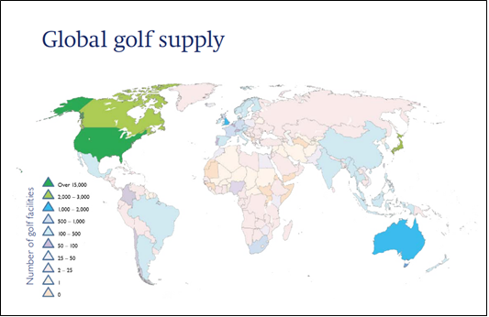

As shown above, the countries are colour coded for amount of golfing facilities. file://e4039s01sv001.indigo.schools.internal/fsE4039S01-StudentFolders$/cohen.sheridan/Downloads/Golf%20around%20the%20world%202017%20(1).pdf

6.0 Likely future changes in the nature and spatial distribution of Democracy
There were 33,161 golf courses in 208 of the world's 245 countries as of the end of 2016. That equates to an 85 percent global diffusion rate for the sport in 2016-17.
Golf is dropping in uptake from kids and golf memberships are also declining. In the United States, it indicates that the number of people who play golf on a regular basis has decreased from 30 million in 2002 to 21 million in 2016, with the downward trend continuing well into 2021. There are a variety of causes for this fall.
As shown below, the decreasing amount of people’s interest in golf.
https://southamptongolfclub.com/is-golf-really-a-dying-sport/

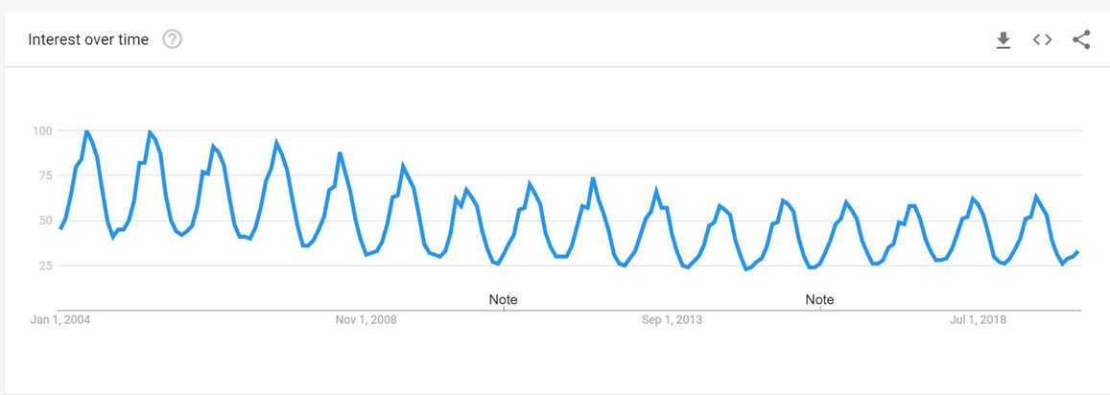

-As people become less interested in golf, its business value diminishes, which is another cause for the sport's decline.
-Due of the covid-19 crisis, people's disposable incomes are decreasing, and golf is a needless activity that many have eliminated in order to save money.
-While the youth of the Western world are now becoming obese and unproductive, the youth of Asia are seeing an increasing number of Asian players on the PGA tour and see golf as a terrific opportunity to have fun and even a profession.
While the number of courses under development in the United States, the United Kingdom, and Europe continues to decline, the opposite can be stated for Asian countries such as Singapore, Thailand, and China, where the youth are falling in love with the game as their GDPs expand rapidly.
Millions of new people are taking up the sport in Asia because it is something fresh and exciting from the west which was not available to those who came before them, and the sport is thriving as a result.
However, if the Asian population continues to embrace the game, the number of Asian players on the tour will undoubtedly rise, and the future of golf may well lie in Asia rather than the United States.

7.0 Bibliography
• WA ATAR geography text book.
Griffin, A., Michie, D. and Smith, T., 2016. WA ATAR geography. PERTH: GAWA, p. Unit 2.

• En.wikipedia.org. 2021. St Andrews (New) railway station - Wikipedia. [online] Available at: https://en.wikipedia.org/wiki/St_Andrews_(New)_railway_station [Accessed 14 September 2021].

• En.wikipedia.org. 2021. PGA Tour - Wikipedia. [online] Available at: <https://en.wikipedia.org/wiki/PGA_Tour> [Accessed 6 September 2021].

• Juneja, P., 2021. Print Advertising - Newspapers, Magazines, Brochures and Fliers. [online] Managementstudyguide.com. Available at: <https://www.managementstudyguide.com/print-advertising.htm> [Accessed 9 September 2021].

• Limited, A., 2021. Stock Photo - Original 1920s vintage print advertisement from English country gentleman's newspaper advertising aluminium golf tee by the Bifurcated & Tubular Rivet Co. of Aylesbury Bucks. [online] Alamy. Available at: <https://www.alamy.com/stock-photo-original-1920s-vintage-print-advertisement-from-english-country-gentlemans-53981722.html> [Accessed 13 September 2021].

• Movies, radio, and sports in the 1920s. 2021. Movies, radio, and sports in the 1920s (article) | Khan Academy. [online] Available at: <https://www.khanacademy.org/humanities/us-history/rise-to-world-power/1920s-america/a/movies-cinema-sports-1920s>
[Accessed 3 September 2021].

• Plate, A., 2021. 1920s Uk Golf 1920s Magazine High Resolution Stock Photography and Images - Alamy. [online] Alamy.com. Available at: <https://www.alamy.com/stock-photo/1920s-uk-golf-1920s-magazine.html> [Accessed 13 September 2021].

• Southampton golf club., 2021. Is Golf Really a Dying Sport – A Look At The Future Of Golf - (MUST READ Before You Buy). [online] IS GOLF REALLY A DYING SPORT – A LOOK AT THE FUTURE OF GOLF. Available at: <https://southamptongolfclub.com/is-golf-really-a-dying-sport/> [Accessed 22 September 2021].

• The Guardian. 2021. Slum golf: the sport that stormed the streets of Mumbai. [online] Available at: <https://www.theguardian.com/cities/2019/feb/11/slum-golf-the-sport-that-stormed-the-streets-of-mumbai> [Accessed 8 September 2021].

• Chapter 4: Folk and Popular CultureSps186.org. 2021. Chapter 4: Folk and Popular Culture. [online] Available at: <https://www.sps186.org/downloads/attachments/33832/Chapter%204%20Reading%20Guide.pdf> [Accessed 13 September 2021].

